X= 1 to 1015 & find the Error

i=-1;

D=[];

a1=[];

a2=[];

a3=[];

while i<=13

i=i+1;

x=10^(i+1);

f1= sqrt(x)*(sqrt(x+1)-sqrt(x));

f2= sqrt(x)/(sqrt(x+1)+ sqrt(x));

f1=vpa(f1,20);

f2=vpa(f2,20);

e=f1-f2;

e=vpa(e,20);

x=vpa(x,20);

D=[D;x];

a1=[a1;f1];

a2=[a2;f2];

a3=[a3;e];

matrix=[D,a1,a2,a3];

end

% Define column names

column_names = {'Values', 'FUNCTION ONE', 'FUNCTION TWO' , 'ERROR'};

% Create a table with the matrix and column names

table_with_column_names = array2table(matrix, 'VariableNames', column_names)

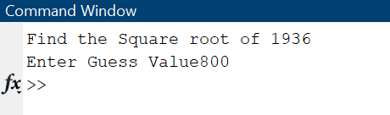

x=input("Find the Square root of ")

g=input("Enter Guess Value")

co=1;

while g*g-x > 1e-4

g=(g+x/g)/2

co=co+1;

end

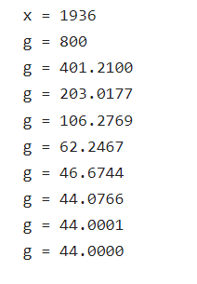

Output

$$f1\left(x\right)=\frac{1-\sin\left(x\right)}{x^{2}}$$

$$f2\left(x\right)=\frac{{\left(\cos\left(x\right)\right)}^{2}}{(x^{2} (1+\sin\left(x\right))}$$

x= 10 to 1020

i=0;

a1=[];

a2=[];

a3=[];

a4=[];

while i<=20

i=i+1;

x=10^(1+i);

x=vpa(x,22);

a1=[a1;x];

f1=(1-sin(x))/x^2;

f2=((cos(x))^2)/(x^2*(1+ sin(x)));

f1=vpa(f1,22);

f2=vpa(f2,22);

a2=[a2;f1];

a3=[a3;f2];

er=f1-f2;

a4=[a4;er];

mat=[a1,a2 a3 a4];

end

cname={'Value','F1','F2','Error'}

tb=array2table(mat , 'VariableNames',cname)

k=-20;

z=[];

while k<=20

k=k+1;

f=(1/sqrt(2*pi));

x=exp((-k^2)/2);

y=x*f ;

y=vpa(y,16);

z=[z;y];

end

disp(z)

d=linspace(-20,21,41)

plot(d,z)

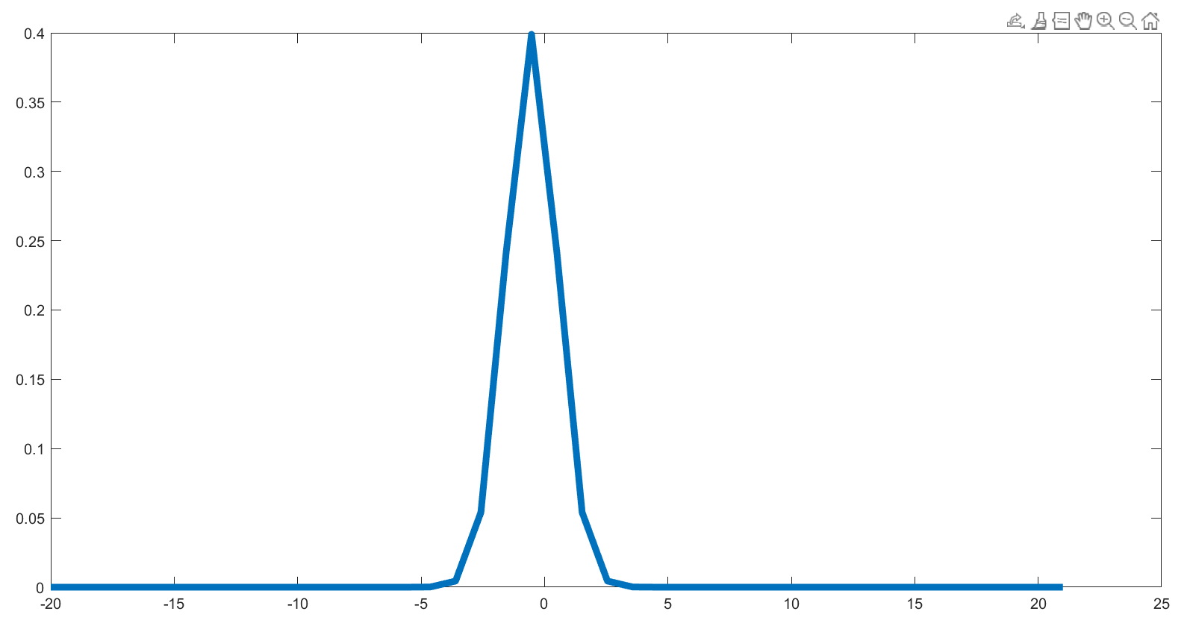

Golden Ratio

x=-1:0.0001:3;

y=x;

x2=sqrt(x+1);

hold on

plot(x,y)

plot(x,x2)

